CHANGES HISTORY
PIC | Date | Remarks
BJM.MR | 2018.05.04 | Created
Ghaida | 2018.05.04

TOC
- Parameter Portfolio Account
- Parameter Portfolio Level
- Parameter Portfolio Days
- Parameter Portfolio Type
- Parameter Portfolio Status
- Parameter Portfolio Asset Type
- Parameter Portfolio Return
- Parameter Portfolio Benchmark Type
- Parameter Portfolio Over ride Type
- Parameter Portfolio Transaction Apply

Diagram ENTITY RELATIONSHIP

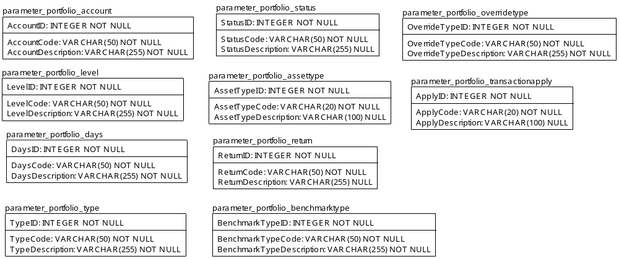

TABLE RELATIONSHIP
No | Table 1 | Table 2 | Type (1:1; 1:N; M:N) | Description

Name |  | parameter_portfolio_account
Objective
No | Column |  | Type | Rule  (PK, FK, Key, NN, Unik, Index) | Description
1. | AccountID |  | Integer | NN
2. | AccountCode |  | Varchar(50) | NN
3. | AccountDescription |  | Varchar(255) | NN

SAMPLE DATA
No | Column | Sample 1 | Sample 2 | Sample 3 | Sample 4
1. | AccountID | 1 | 2
2. | AccountCode | DISCRETIONARY FUND | MUTUAL FUND
3. | AccountDescription | Discretionary Fund | Mutual Fund

Name |  | parameter_portfolio_level
Objective
No | Column |  | Type | Rule  (PK, FK, Key, NN, Unik, Index) | Description
1. | LevelID |  | Integer | NN
2. | LevelCode |  | Varchar(50) | NN
3. | LevelDescription |  | Varchar(255) | NN

SAMPLE DATA
No | Column | Sample 1 | Sample 2 | Sample 3 | Sample 4
1. | LevelID
2. | LevelCode
3. | LevelDescription

Name |  | parameter_portfolio_days
Objective
No | Column |  | Type | Rule  (PK, FK, Key, NN, Unik, Index) | Description
1. | DaysID |  | Integer | NN
2. | DaysCode |  | Varchar(50) | NN
3. | DaysDescription |  | Varchar(255) | NN

SAMPLE DATA
No | Column | Sample 1 | Sample 2 | Sample 3 | Sample 4
1. | DaysID | 1 | 2 | 3
2. | DaysCode | ACTUAL | END OF MONTH | 30/360
3. | DaysDescription | ACTUAL/ACTUAL | END OF MONTH | 30/360

Name |  | parameter_portfolio_type
Objective
No | Column |  | Type | Rule  (PK, FK, Key, NN, Unik, Index) | Description
1. | TypeID |  | Integer | NN
2. | TypeCode |  | Varchar(50) | NN
3. | TypeDescription |  | Varchar(255) | NN

SAMPLE DATA
No | Column | Sample 1 | Sample 2 | Sample 3 | Sample 4
1. | TypeID | 1 | 2 | 3 | 4
2. | TypeCode | PORTFOLIO | SUB PORTFOLIO | UMBRELLA FUND | MULTI CURRENCY
3. | TypeDescription | Portfolio that had transaction | Portfolio of some asset type from one source portfolio | Group portfolio with same currency | Group portfolio with more than one currency

Name |  | parameter_portfolio_status
Objective
No | Column |  | Type | Rule  (PK, FK, Key, NN, Unik, Index) | Description
1. | StatusID |  | Integer | NN
2. | StatusCode |  | Varchar(50) | NN
3. | StatusDescription |  | Varchar(255) | Null

SAMPLE DATA
No | Column | Sample 1 | Sample 2 | Sample 3 | Sample 4
1. | StatusID | 1 | 2 | 3 | 4
2. | StatusCode | PENDING | ACTIVE | SUSPEND | CLOSE
3. | StatusDescription | Pending | Active | Suspend | Close

Name |  | parameter_portfolio_assettype
Objective
No | Column |  | Type | Rule  (PK, FK, Key, NN, Unik, Index) | Description
1. | AssetID |  | Integer | NN
2. | AssetCode |  | Varchar(20) | NN
3. | AssetDescription |  | Varchar(100) | Null

SAMPLE DATA
No | Column | Sample 1 | Sample 2 | Sample 3 | Sample 4
1. | AssetID | 1 | 2 | 3 | 4
2. | AssetCode | EQ | FI | MIX | MM
3. | AssetDescription | Equities | Fixed Income | Mixed asset | Money market

Name |  | parameter_portfolio_assettype
Objective
No | Column |  | Type | Rule  (PK, FK, Key, NN, Unik, Index) | Description
1. | AssetID |  | Integer | NN
2. | AssetCode |  | Varchar(50) | NN
3. | AssetDescription |  | Varchar(255) | Null

SAMPLE DATA
No | Column | Sample 1 | Sample 2 | Sample 3 | Sample 4
1. | AssetID | 1 | 2 | 3 | 4
2. | AssetCode | EQ | FI | MIX | MM
3. | AssetDescription | Equities | Fixed Income | Mixed asset | Money market

Name |  | parameter_portfolio_return
Objective
No | Column |  | Type | Rule  (PK, FK, Key, NN, Unik, Index) | Description
1. | ReturnID |  | Integer | NN
2. | ReturnCode |  | Varchar(50) | NN
3. | ReturnDescription |  | Varchar(255) | Null

SAMPLE DATA
No | Column | Sample 1 | Sample 2 | Sample 3 | Sample 4
1. | ReturnID | 1 | 2
2. | ReturnCode | UNIT PRICING | DAILY TTW (NAV)
3. | ReturnDescription | Performance by NAV/Unit | Daily True Time Weighted Return by AUM

Name |  | parameter_portfolio_benchmarktype
Objective
No | Column |  | Type | Rule  (PK, FK, Key, NN, Unik, Index) | Description
1. | BenchmarkTypeID |  | Integer | NN
2. | BenchmarkTypeCode |  | Varchar(50) | NN
3. | BenchmarkTypeDescription |  | Varchar(255) | NN

SAMPLE DATA
No | Column | Sample 1 | Sample 2 | Sample 3 | Sample 4
1. | BenchmarkTypeID | 1 | 2
2. | BenchmarkTypeCode | BENCHMARK | PORTFOLIO
3. | BenchmarkTypeDescription | Use benchmark like equities index, average time deposit rate, etc | Use another portfolio performance as benchmarking

Name |  | parameter_portfolio_overridetype
Objective
No | Column |  | Type | Rule  (PK, FK, Key, NN, Unik, Index) | Description
1. | OverrideTypeID |  | Integer | NN
2. | OverrideTypeCode |  | Varchar(50) | NN
3. | OverrideTypeDescription |  | Varchar(255) | NN

SAMPLE DATA
No | Column | Sample 1 | Sample 2 | Sample 3 | Sample 4
1. | OverrideTypeID | 1 | 2 | 3
2. | OverrideTypeCode | NO | OVERRIDE | ADJUSTMENT
3. | OverrideTypeDescription | NAV & Asset can not be override from external source | NAV & Asset can be override from external source | NAV & Asset can be adjusted by adjustment transaction from external source

Name |  | parameter_portfolio_transactionapply
Objective
No | Column |  | Type | Rule  (PK, FK, Key, NN, Unik, Index) | Description
1. | ApplyD |  | Integer | NN
2. | ApplyCode |  | Varchar(20) | NN
3. | ApplyDescription |  | Varchar(100) | Null

SAMPLE DATA
No | Column | Sample 1 | Sample 2 | Sample 3 | Sample 4
1. | BenchmarkTypeID | 1 | 2
2. | BenchmarkTypeCode | YES | NO
3. | BenchmarkTypeDescription | Portfolio permitted to have transaction | Portfolio not permitted to have transaction

